http://www.mundoviejuno.com/blog.htm

Good morning everyone! How long without updating the blog :)

Well, today I am going to comment on a topic that I had been doing for some time, which is a complete mode to the model that was my first computer, the Atari PC-1

The PC-1 was Atari's first attempt to get into the world of compatible PCs.

[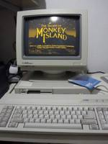](http://chan.vieju.net/src/1340963993793.jpg)  
A factory PC-1 running the Monkey Island

This was intended to deal with IBM, offering a better product than your PC / XT, and even offering an economical alternative to your PC / AT. Here are its features:

• Intel 8088 CPU at 8 mhz

• 512kb ram

• EGA graphics card

• Disketera of 5 1/4

The equipment came in a very similar housing to that of the Atari Mega ST4 and could use its same mouse, disketeras and external hard drives. So they had thought of sharing peripherals while getting into the PC compatible market.

In short, a clone of the PC / XT but in a design housing and much thinner than what we were used to in the pc world, where the much larger cases abound (something more than a 5 1/4 double height while that this Atari would be something more than a 5 1/4 simple height).

The disadvantage of this? The possibilities of expansion. With such a thin case, we can imagine that there is no possibility of puncturing ISA cards, but even less when we see the motherboard:

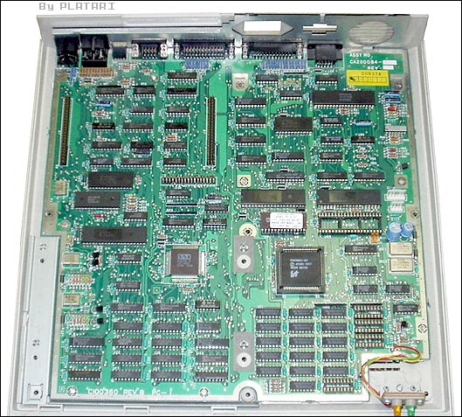  
There are no ISA slots anywhere!

Surely there are no isa slots, so except to expand the memory and put an 8087 coprocessor ... there is no way to improve the team ... or if?

**Modding part 1: Inclusion of ISA slots**

In the upper left we see two mysterious 50-pin connectors. It seems that they were connectors for an external hard drive, which was in a shell similar to that of the Atari, was placed on top of it and contained an MFM disk of 20mb. This was the only possibility of 'internal' expansion that the team had ...

[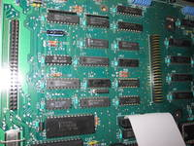](http://chan.vieju.net/src/1364055635386.jpg)  
The mysterious connectors J2 and J8, which will be?

Thinking about how possibly those connectors were, if not the whole set, at least a subset of signals from the ISA bus that would allow me to connect more hardware to the Atari, I got in touch with Curt Vendel from [AtariAge](https://translate.googleusercontent.com/translate_c?depth=1&rurl=translate.google.com&sl=auto&sp=nmt4&tl=en&u=http://www.atariage.com/&xid=17259,15700021,15700186,15700190,15700248&usg=ALkJrhhZkeFMLtnWjsaYPTzlC5yGnbxvjw) . Luckily, Curt had the original Atari PC-1 schemes and was kind enough to send them to me. Thank you Curt!

[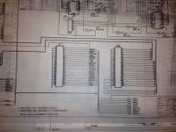](http://chan.vieju.net/src/1362264037928.jpg)  
Original schemes of PC-1!

Effectively in those two connectors was the whole signal set of the bus isa, which, at least in theory, we could connect standard ISA cards to the PC-1 :)

With this in mind, I started making an adapter so that, in addition to being able to add cards to the Atari, I could keep its original housing. For this I started with an IBM 16-bit risercard that I did 'lose weight' to adapt to 8 bits and that was not too high:

[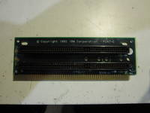](http://chan.vieju.net/src/1364055395553.jpg)  
16-bit Risercard ...

[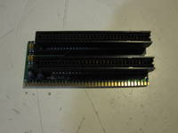](http://chan.vieju.net/src/1364055448836.jpg)  
... become one of 8

Then, it is a question of adapting the riser to connectors J2 and J8, for that we are going to use some flexible cable strips that we solder to this risercard ...

[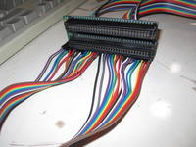](http://chan.vieju.net/src/1364055555128.jpg)  
Personalized Risercard!

... we identify pin to pin each of the signals of the ISAs of the risercard ...

[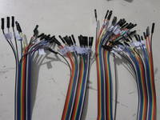](http://chan.vieju.net/src/1364055746467.jpg)  
Patience and time ....

... and now it only remains to connect each one of those pins to each one of the pins of J2 and J8, so in theory the system will be ready ... but, what are we going to put in the Atari?

One thing was clear, a hard disk was missing, that in his day he missed it a lot, and already we could improve the sound ... said and done, an XT-IDE controller and a Sound Blaster Pro 2:

[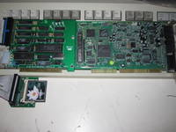](http://chan.vieju.net/src/1364055686368.jpg)  
The two cards for the Atari :)

We connect everything ...

[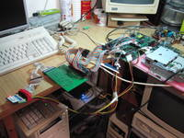](http://chan.vieju.net/src/1364055800289.jpg)  
First test of the new ISA slots!

And bingo! It works perfectly!

To save space as a hard disk we use a Compact Flash card with an IDE adapter. Specifically here I used a 256mb CF, which for a team like this is more than enough.

**Modding part 2: Memory expansion**

This part is undoubtedly the one that has been easiest in the entire modding process. It has only consisted in populating these empty zocalos with the corresponding memories ...

[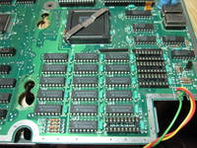](http://chan.vieju.net/src/1365426492282.jpg)  
Sockets to extend your memory

**Modding part 3: Overclock**

Here is one of my biggest doubts: How would this PC model be overclokeable?

After a quick inspection, we can see in the previous photograph how there are two oscillators near 8088, one at 24mhz and another at 14.318mhz. Knowing that the turbo speed of the PC-1 is 8 mhz and that the standard is 4.77 mhz ... and seeing that the frequency of these oscillators is just the third multiplo ... well it is clear. An oscillator controls the bus isa and the cpu when it is in normal mode (14mhz) and another cpu in turbo mode. It is therefore a matter of changing this oscillator.

After tests with several oscillators I decide to stay with one of 32 mhz, which results in an effective frequency of 32/3 = 10.66 mhz. Higher values ​​only made the system unstable or not even start.

Well, 2.66 mhz more, it's not bad, but now there is an extra problem, there is a support chip that overheats, the DMA 8237 controller

[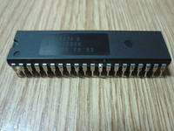](http://chan.vieju.net/src/1365426639535.jpg)  
The 8237 of the desoldered Atari

Since it is an integrated with plastic encapsulation it does not dissipate as well as a ceramic one, so I exchange it for one of the latter ...

[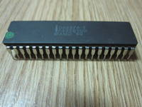](http://chan.vieju.net/src/1365426668085.jpg)  
A ceramic 8237 :)

And I add a custom made heatsink:

[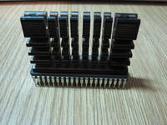](http://chan.vieju.net/src/1365426693787.jpg)  
8237 ceramic with dissipator

We just need to find a cpu that works well at these 10.66 mhz, and in turn exchange the 8088 for its equivalent Nec, we will use a v20hl, which allows up to 16mhz:

[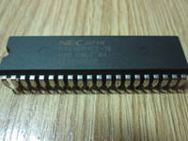](http://chan.vieju.net/src/1365426730093.jpg)  
v20hl

Once installed and working the system is completely stable, and since the v20hl is prepared to work at 16mhz at 10.66 or is not heated, no need to put heatsink.

[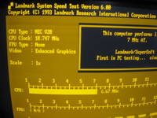](http://chan.vieju.net/src/1365427911452.jpg)  
Full overclocking!

**Modding part 4: Coprocessor 8087**

We are running out of things to add to the Atari PC-1, but we still have the socket of the free 8087 math coprocessor, so let's adapt one.

As we have increased the speed of the system to more than 10mhz it is necessary to look for a specific coprocessor model, since only one was designed to operate at 10mhz, the 8087-1

[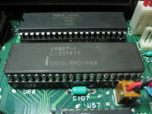](http://chan.vieju.net/src/1365426791899.jpg)  
v20hl and 8087-1 in their sockets

Since it is designed to work at 10mhz and here we are taking it to 10.66mhz, we are forcing it a bit .. In fact, it heats up a lot and with several minutes of operation the system becomes unstable ...

... which we solved by making a new custom heatsink:

[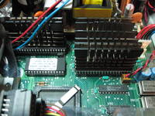](http://chan.vieju.net/src/1365426815610.jpg)  
All heatsinks installed!

Once installed, the system is stable:

[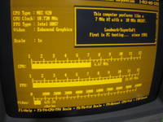](http://chan.vieju.net/src/1365428136750.jpg)  
v20 and 8087 running both at 10.7 mhz

**Modding part 5: Final**

After all the modifications we can only fit and isolate everything ...

[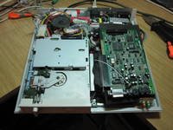](http://chan.vieju.net/src/1364738526258.jpg)  
Everything fitted!

And we went to close the case and put the screws ...

[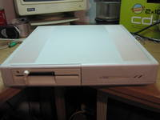](http://chan.vieju.net/src/1364738576084.jpg)  
Nothing stands out! Checked!

It seems incredible that everything fits there with how fine the cpu is :)

After installing it and changing your original yellow phosphor monitor with an EGA color so you can see games like Cobra Mission ...

[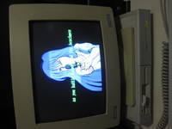](http://chan.vieju.net/src/1364738605951.jpg)  
Cobra Mission!

... Catacomb Abyss 3d ...

[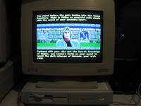](http://chan.vieju.net/src/1365351973505.jpg)  
Catacomb Abyss

And I was even encouraged and I started to install Windows 3.0, which in EGA high resolution also looks very good :)

[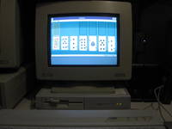](http://chan.vieju.net/src/1365351926235.jpg)  
A little game for the loner?

Well, and that's it, now it's a real joy to enjoy this team. It is more agile, it has more memory, hard disk, better sound, color monitor ... a very important change ... in any case I hope you liked the whole process. A greeting!